**Prevent and Counter Terrorism Strategy**

**Introduction**

The Counter Terrorism and Security Act 2015 (updated 21/04/2021) aims to prevent people from being drawn into terrorism and it highlights the need to be vigilant and that we all have a shared responsibility for safeguarding and promoting community cohesion. The Prevent agenda includes: international terrorism, Islamist ideology, Right / Neo Nazi / White Supremacist ideology, Incels, Irish Nationalists and Loyalist paramilitary groups and extremist Animal Rights movement. Learning & Skills is an inclusive training and education provider for children, young people, adults and families, including people from ethnically diverse and socially and economically disadvantaged areas and we value and respect responsible freedom of speech.

**Key Definitions**

**Radicalisation:** the process by which a person comes to support terrorism and extremism leading to terrorism.

**Extremism**: Vocal or active opposition to fundamental British values, including democracy, the rule of law, individual liberty and mutual respect and tolerance of different faiths and beliefs. Also included in the definition of extremism are calls for the death of members of our armed forces.

The L&S Prevent and Counter Terrorism Strategy objectives:

* to provide appropriate advice and support to prevent people from being drawn into terrorism and ensure they receive the relevant external help
* to challenge the concept of terrorism, extremism and the threat faced from those who promote these views
* to ensure staff, volunteers and learners are aware of their roles and responsibilities and that L&S has a zero-tolerance approach to bullying, harassment, hate crime and discrimination
* to work in partnership with a range of agencies when there are risks of radicalisation including: police, local communities, health, schools, voluntary sector, charities and faith organisations
* to offer staff, volunteers and learners local and national updates to provide understanding of the issues and have the confidence to deal with them
* to provide an inclusive and flexible curriculum which promotes equality and diversity, challenges extremist accounts and promotes universal rights
* to encourage an inclusive and social cohesive service, with recognition for all faith and cultures and celebrate diversity
* to promote L&S and British values; to enable a forum for open and safe debate so learners have a voice

There is no specific terrorist threat to County Durham and Darlington (Durham Constabulary 2021). However, terrorism remains a real and serious threat to us all. Terrorist and violent extremism activity aims to damage community relations, undermine the values we share and create divisions. The UK Government has a long-term strategy for countering terrorism known as CONTEST. The aim of CONTEST is to reduce the risk to the UK and its citizens and interests overseas from terrorism, so that people can go about their lives freely and with confidence. CONTEST strategy has four strands:

|  |  |  |
| --- | --- | --- |
| **CONTEST’s Risk Reduction Model** | | **Primary Outcome** |
| **Prevent** | Safeguard people from becoming terrorists or supporting terrorism | Reduce intent |
| **Pursue** | Stop terrorist attacks happening in the UK and  oversees | Reduce capability |
| **Protect** | Strengthen our protection against a terrorist attack in the UK or oversees | Reduce vulnerability |
| **Prepare** | Mitigate the impact of a terrorist incidents if it occurs | Reduce impact |

**Marauding terrorist attack** (MTA) is a fast-moving attack where assailants move through a location aiming to find and cause harm to as many people as possible.

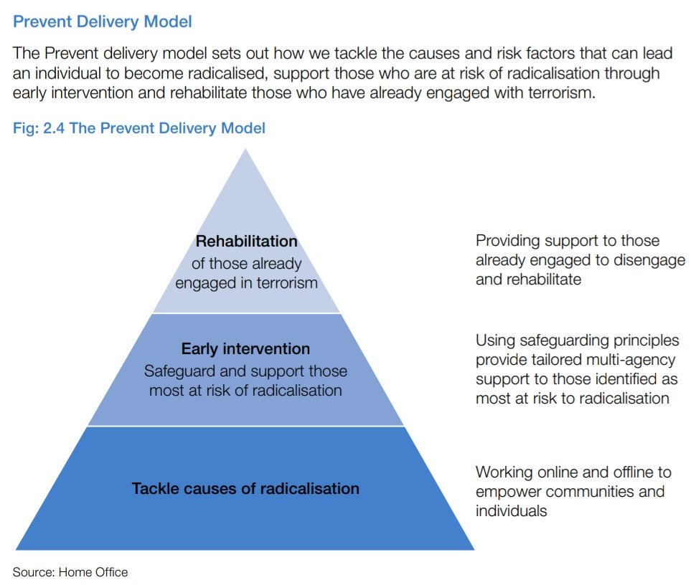

**Channel**

The multi-agency approach to protect people at risk from radicalisation is called Channel. This uses existing collaboration between local authorities, statutory partners (such as the education and health sectors, social services, children and youth services and offender management services), the police and the local community to:

* Identify individuals at risk of radicalisation or involvement in terrorism
* Assess the nature and extent of that risk and
* Develop the most appropriate support plan for the individuals concerned

Channel is about safeguarding children and adults from being drawn into involvement in terrorism. It is about early intervention to address vulnerabilities and divert people from harm.

**Darlington’s Referral Pathway**

**What to do if you have a concern:** If you have a concern that a child / young person or adult

may be at risk of radicalisation or involvement in terrorism, you should speak with the Service:

**Designated Safeguarding Lead / Single Point of Contact (SPOC):**

Alaine McCartney, Learning & Skills Manager

Email [alaine.mccartney@darlington.gov.uk](mailto:alaine.mccartney@darlington.gov.uk)

Telephone: 07816 677851

**Designated Safeguarding Deputy:**

Mally Bleasby, Study Programme Manager

Email [malcolm.bleasby@darlington.gov.uk](mailto:malcolm.bleasby@darlington.gov.uk)

Telephone: 01325 406422 / 07983 996144

**Designated Safeguarding Deputy:**

Graham Curry, Apprenticeship Manager

Email [graham.curry@darlington.gov.uk](mailto:graham.curry@darlington.gov.uk)

Telephone: 01325 405602 / 07949 845325

**Key Contacts and Further Support**

**Children’s Initial Advice Team (CIAT)** open during the following hours: Monday - Thursday: 8:30am - 5pm & Friday: 8:30am - 4:30pm

Telephone: Professionals 01325 406252 / Public 01325 406222

E-mail: [childrensfrontdoor@darlington.gov.uk](mailto:childrensfrontdoor@darlington.gov.uk)

If you need to get in touch out of office hours and bank holidays, contact the Emergency Duty Team on **01642 524552**

**First Point of Contact Team (Adults)** open during the following hours: Monday - Friday: 9:00am - 5pm

Telephone: 01325 406111 / Text 07538 601527

E-mail: [ssact@darlington.gov.uk](mailto:ssact@darlington.gov.uk)

Concern form: <https://www.darlington-safeguarding-partnership.co.uk/about-us/worried-about-an-adult/>

If you need to get in touch out of office hours and bank holidays, contact the Emergency Duty Team on **01642 524552**

**Education:**

Joanna Conway - Education Safeguarding Officer

Email [Joanna.Conway@darlington.gov.uk](mailto:Joanna.Conway@darlington.gov.uk)

Telephone: 01325 405848 / 07940000845

**Darlington Borough Council Prevent Lead**

Graham Hall, Head of Community Safety

Email [graham.hall@darlington.gov.uk](mailto:graham.hall@darlington.gov.uk)

Telephone: 01325 406754

**Channel Panel:**

Jo Benson – Youth Offending Manager

Email [joanne.benson@darlington.gov.uk](mailto:joanne.benson@darlington.gov.uk)

Telephone: 01325 406791

**Call 999 if there is an immediate threat to life.**

**Police Prevent Team** (office hours) 0191 375 2234 / [prevent@durham.pnn.police.uk](mailto:prevent@durham.pnn.police.uk)

If you have information about possible terrorist activity call Durham Constabulary on 101 for non-urgent and 999 for emergency calls.

**To report illegal information, pictures or videos found on the internet**

[www.gov.uk/report-terrorism](http://www.gov.uk/report-terrorism)

**Confidential National Anti-terrorist hotline:** 0800 789 321

**Due Diligence and Counter Extremism Group** (DDCEG) Helpline - (020 7340 7264) For education staff and governors to raise concerns relating to extremism directly and in confidence

<http://educateagainsthate.com/>



<https://actearly.uk/>

[https://assets.publishing.service.gov.uk/government/uploads/system/uploads/attachment_data](https://assets.publishing.service.gov.uk/government/uploads/system/uploads/attachment_data/file/716907/140618_CCS207_CCS0218929798-1_CONTEST_3.0_WEB.pdf)

<https://www.cpni.gov.uk/>

https://www.durham.police.uk/Information-and-advice/counter-terrorism/Pages/default.aspx

<https://www.et-foundation.co.uk/supporting/professional-development/inclusion/prevent//>

<https://www.gov.uk/government/publications/channel-guidance>

<http://www.gov.uk/government/publications/prevent-duty-guidance>

<https://www.gov.uk/government/publications/prevent-duty-guidance>

<https://www.gov.uk/government/publications/protecting-children-from-radicalisation-the-prevent-duty>

https://www.ltai.info/what-is-prevent/

**Prevent Duty Risk**

|  |  |  |  |  |  |
| --- | --- | --- | --- | --- | --- |
| **No** | **Prevent Vulnerability/Risk Area** | **Action taken/already in place to mitigate/address risk** | **Owner** | **When** | **RAG** |
| 1 | **Leadership:**   1. Local Authority Management 2. SLT 3. Staff 4. Safeguarding team | a) All staff including Leaders complete Prevent via Academy 10 and Prevent Duty is discussed by Council. Directors annual report in July.  Assistant Director briefed on Prevent threat/risk.  b) SLT members are WRAP trained, contribute to developing the Prevent Strategy and receive monthly updates.  c) All staff including volunteers have completed Prevent online – DSCB & Home Office.  All Prevent training recorded on the Single Central Record and refresher every 3 years.  d) DSL & DSPs have completed Prevent & Channel online. WRAP, Train the Trainer and L3 Safeguarding.  Safeguarding / Prevent Working Group bi-monthly.  Action Plan reviewed every month. | Paul  Alaine  Alaine  Alaine, Graham & Mally | 29/07/2022  Termly  29/07/2022  Monthly  29/07/2022  Monthly  10/12/2021  Bi-monthly | **G**  **G**  **G**  **A** |
| 2 | **Partnership:**   1. Is there active engagement from the institution's SLT, managers and leaders? 2. Does the institution have an identified single point of contact (SPOC) in relation to Prevent? 3. Does the institution engage with Local Authority Police Prevent Leads and engage with local Prevent Boards/Steering Groups at Strategic and Operational level? | a) DBC internal communications and podcast from Managing Director. Information sharing from the Education DSL & Community Resilience. Education Quarterly Report includes information of any Prevent activity or threat/risk to L&S /DBC.  b) DSL is the Service SPOC, during absence DSD in attendance at all times. Induction PowerPoint, Learner Handbook, Safeguarding poster.  c) Chris SybengaG7-Prevent Regional HE/FE Co-ordinator DfE / Andrew Allinson, Community Resilience / Joanna Conway DSL Education /  Silver Group / Professional Exchange North East. | Paul  Alaine  Alaine | 29/07/2022  29/07/2022  01/09/2022 | **G**  **G**  **G** |
| 3 | **Staff Training:**   1. Exemplify British Values in their management, teaching and through general behaviours in the institution? 2. Understand the factors that make people vulnerable to being drawn into terrorism and to challenge extremist ideas which are used by terrorist groups and can purport to legitimise terrorism? 3. Have sufficient training to be able to recognise this vulnerability and be aware of what action to take in response? 4. Have front line staff got the tools and knowledge to impart knowledge of Prevent in a contextualised way? | a) Corporate induction, Walkthrough themes, circulated good practice, OLTA, Padlet, Best Practice Toolkit.  b) All staff encouraged to attend Staff Briefings with a focus on BV and Prevent Duty.  Bi-weekly quiz with detailed answers produced by teaching staff  Monthly NE Newsletter from the DfE.  c) Annual Prevent health check for all staff to identify training need. 100% of staff and volunteers have completed Prevent online – DSCB & Home Office. 100% of staff and volunteers have completed WRAP training.  d) Identify and stop unauthorised visitors training.  Visitor Information Card. | SLT  All Staff  Alaine  Alaine | 29/07/2022  29/07/2022  Week/Month  22/11/2022  29/07/2022 | **G**  **G**  **A**  **G** |
| 4 | **Welfare and pastoral support:**   1. Are there adequate arrangements and resources in place to provide pastoral care and support as required by the institution? 2. Are their adequate monitoring arrangements to ensure that this support is effective and supports the institutions welfare and equality policies? 3. Does the support reflect the learner’s demographic and need? | a) Referral procedure for the Service Mentor and Career Guidance Adviser and Intensive Support. Cause for Concern process. Alliance Counselling.  b) Coordinated approach is taken to support learners who may be vulnerable. Individual Intervention observation, ILPs.  c) ILPs inclusive and responsive to need. S:\L&S\IntensiveSupport\ISData. ILR postcode. | Chloe, Tammy & SLT  Chloe, Tammy & QIG  Chloe & Tammy | 29/07/2022  17/12/2022  29/07/2022 | **G**  **A**  **G** |
| 5 | **Speakers and Events:**   1. Is there an effective policy/framework for managing speaker requests? 2. Is it well communicated to staff/learners and complied with? 3. Is there a framework for managing events? 4. Are off site events which are supported, endorsed, funded or organised through the institution subject to policy/framework? | a) S:\Learning and Skills\QA Policies\External Speakers Policy  b) WISE    c) S:\L&S\Safeguarding\Prevent\Guest Speaker Risk Assessment and S:\L&S\Risk Assessments  d) Enrolment form signed declaration,  S:\L&S\ QA Policies\Code of Conduct and S:\L&S\ QA Policies\Health & Safety | Alaine  Karen  Alaine  QIG | 01/06/2022  29/07/2022  29/07/2022  29/07/2022 | **G**  **G**  **G**  **G** |
| 6 | **Safety Online:**   1. Does the institution have a policy relating to the use of IT and does it contain a specific reference and inclusion of the Prevent Duty? 2. Does the institution employ filtering/firewall systems to prevent staff/learners/visitors from accessing extremist websites and material? 3. Does this also include the use of using their own devices via Wi-Fi? 4. Does the system alert to serious and/or repeated breaches or attempted breaches of the policy? | a) Acceptable Use Policy  S:\Learning & Skills\QA Policies\AUP  b) Xentrall – McAfee Web Gateway. Category based filtering system  Internal checks conducted every 3 months S:\L&S\Safeguarding\Prevent\Softwarecheck 2019.  c) No.  d) Random checks | Ian & Simon  Simon, Graham & Mally  Xentrall  Xentrall | 30/11/2022  29/07/2022  29/07/2022 | **G**  **G**  **G** |
| 7 | **Learner Knowledge:**   1. Do learners have sufficient knowledge of British Values, Prevent and Radicalisation and understand Radicalisation? 2. Can learners identify when they or a fellow learner might be being radicalised? 3. Do learners know how to report a Prevent Issue? | a) Induction video delivered to all learners.  Learners are encouraged to complete Prevent online. Bi-weekly quiz with learners on relevant themes, walkthroughs, OLTAs, website, posters.  b) Induction video, learner handbook, OLTA, walkthroughs, guest speakers, visual displays.  c) Induction video, learner handbook, displayed posters with DSL / DSD photographs and contact details, bi-weekly quiz. | Alaine & Karen  All Staff  All Staff | 29/07/2022  29/07/2022  29/07/2022 | **G**  **G**  **G** |
| 8 | **Prayer and Faith Facilities:**   1. Does the institution have prayer facilities? | a) No |  |  |  |
| 9 | **Security:**   1. Are there effective arrangements in place to manage access to the buildings by visitors and non-learners/staff? 2. Is there a policy regarding the wearing of ID on site? Is it enforced? 3. Is there a policy covering the distribution (including electronic) of leaflets or other publicising material? | a) All staff, volunteers, learners and visitors sign-in at all L&S venues. Visitor information card distributed at sign-in. Sparta security.  b) All staff must wear an ID badge.  Learner and visitor badges (BV lanyards with alternating themes) not distributed due to Covid. Information is included in the Learner Induction PP.  c) S:\L&S\QAStrategies\Marketing Publicity and Recruitment Strategy. | Alaine  All Staff  SLT  Karen | 29/07/2022  29/07/2022  04/01/2022  01/05/2022 | **G**  **G**  **R**  **G** |
| 10 | **Safeguarding:**   1. Is protection against the risk of radicalisation and extremism included within Safeguarding and other relevant policies? 2. Do safeguarding staff receive additional and ongoing training to enable the effective understanding and handling of referrals relating to radicalisation and extremism? 3. Does the institution utilise Channel as a support mechanism in cases of radicalisation and extremism? 4. Does the institution have a policy regarding referral to Channel identifying a recognised pathway and threshold for referral? | a) S:\L&S\QA Procedure\Safeguarding Procedure  S:\L&S\QA Policies\Safeguarding Policy  Both documents renewed bi-annually.  b) DSL and DSDs receive from the local authority, police, school/college training circulated by Education Safeguarding Officer & Regional HE/FE Prevent Co-ordinator.  c) Yes, and to date DBC has received 6 referrals to Channel. DSL and DSDs have completed the home office Channel online.  d) Prevent Practice Guidance and Channel Process  <http://www.darlingtonsafeguardingboards.co.uk> | Alaine  Alaine, Graham & Mally  Alaine, Graham & Mally  Alaine | 01/02/2022  10/12/2021  29/07/2022  10/12/2021 | **G**  **A**  **G**  **G** |
| 11 | **Communications:**   1. Is the institution Prevent Lead and their role widely known across the institution? 2. Are staff and learners made aware of the Prevent Duty, current risks and appropriate activities in this area? 3. Do learners and staff have Prevent understanding which is more than surface learning? 4. Are there information sharing protocols in place to facilitate information sharing with Prevent partners? | a) Displayed posters with photographs, Induction video, learner handbook, walkthroughs, WISE  b) Local picture and level of risk circulated via monthly NE Newsletter, bi--weekly quiz, staff training.  c) Annual Prevent health check, walkthroughs, OLTAs, QIP.  d) Routes to Work and YEI monthly updates, Padlet, Community Resilience Officer, Education Safeguarding Officer, Tees Valley local Authorities, Regional HE/FE Prevent Co-ordinator. | Alaine  All Staff  Alaine & Karen  Alaine | 29/07/2022  29/07/2022  Week/Month  22/11/2021  Week/Term  29/07/2022 | **G**  **G**  **A**  **G** |
| 12 | **Incident Management:**   1. Does the institution have a critical incident management plan which is capable of dealing terrorist related issues? 2. Is a suitably trained and informed person identified to lead on the response to such an incident? 3. Does the Communications/Media dep’t understand the nature of such an incident and the response that may be required? 4. Does the institution have effective arrangements in place to identify and respond to tensions on or off sites which might impact upon staff, learners and/or public safety? 5. Are effective arrangements in place to ensure that staff and learners are appraised of tensions and provide advice where appropriate? | a) Business Continuity Plan  b) Peter Bodo & Kevin Archbold  Civil Contingencies, Joint response team.  c) Talking to the media and press release co-ordinated by DBC Communication Team  <http://intranetdarlington.gov.uk/communications>  d) Health & Safety, Employer Handbook, Learner Handbook, Risk Assessments, Cause for Concern, Code of Conduct, Comments, Compliments & Complaints.  e) Monthly update and central Communications. | Alaine  Alaine  SLT  SLT & DBC  SLT &  DBC | 01/08/2022  29/07/2022  29/07/2022  29/07/2022  29/07/2022  Monthly | **G**  **G**  **G**  **G**  **G** |
| 13 | **Staff and Volunteers:**   1. Does awareness training extend to volunteers? | a) All volunteers complete Prevent online, Safeguarding Children and Adults, WRAP. | Alaine | 29/07/2022 | **G** |
| 14 | **Freedom of Expression:**   1. Does the institution have a Freedom of Speech/Expression policy? 2. Does this policy recognise and incorporate the risks associated with radicalisation and extremism? 3. Is the need to protect vulnerable individuals covered within this policy? | a) Code of Conduct Policy 2018, Whistleblowing Policy 2018, Social Media Policy 2015, Learner Information Pack  S:\Learning and Skills\QA Policies\External Speakers Policy  b) Learner Information Pack  S:\Learning and Skills\QA Policies\External Speakers Policy  c) Learner Information Pack  S:\L&S\QAProcedure\Safeguarding Procedure  S:\L&S\QAPoloicies\Safeguarding Policies  S:\Learning and Skills\QA Policies\External Speakers Policy  <http://intranet.darlington.gov.uk/services-search/hr/academy-10/academy-10-for-staff/> | Alaine  Alaine  Alaine | 29/07/2022  29/07/2022  29/07/2022  01/02/2022  01/02/2022  01/06/2022 | **G**  **G**  **G** |

|  |  |  |  |
| --- | --- | --- | --- |
| Version | Issued | Next Review | Contact |
| 9 | October 2021 | October 2022 | Alaine McCartney |