Free Early Education Extended Entitlement for Eligible 3 & 4-Year-Olds

EYR2 – How to find your 30 Hours
Code if you have already applied

Some parents have found it difficult to find the 11 digit code once they have successfully applied online. Here is a step-by-step guide to show you how to find it again: Step 1
Click on this link to open the website - https://childcare-support.tax.service.gov.uk/

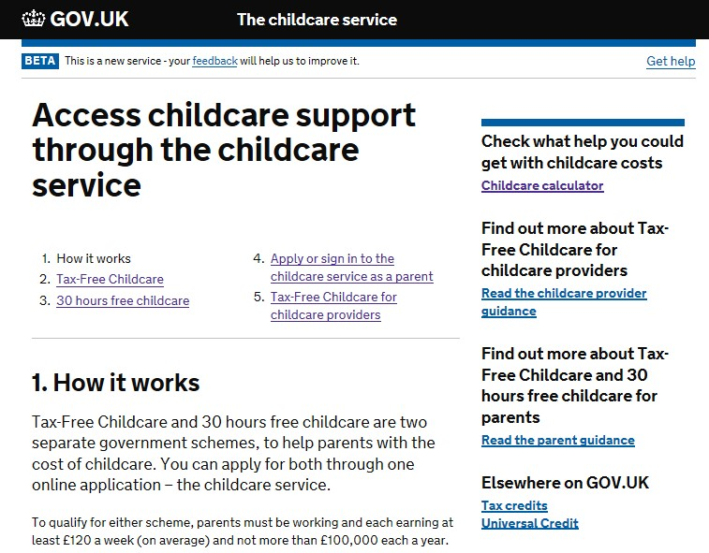

Step 2
Click on number “4. Apply or sign in to the childcare service as a parent”
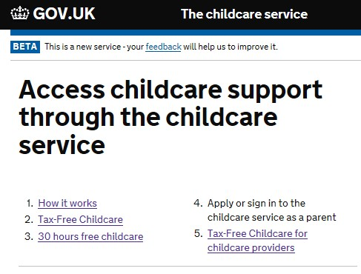

Step 3
Click on the green button at the bottom of the screen labelled ‘Apply or sign in to your account’ (as shown below)
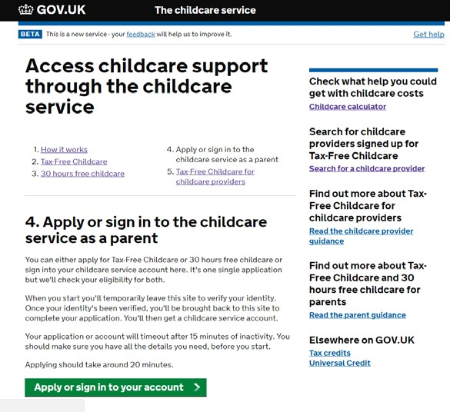

Step 4
Click ‘NO’ to the question about being ‘part of a trial’ and then click the green button labelled ‘Continue’.
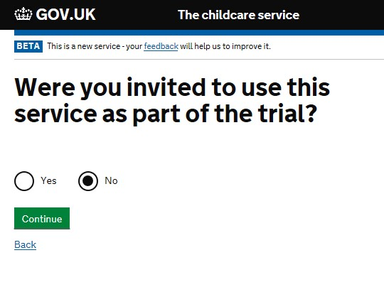

Step 5
Enter your youngest child’s date of birth and then click the green button labelled ‘Continue’.
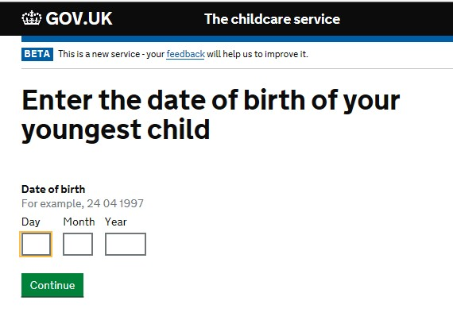

Step 6
Click on the green button labelled ‘Start Now’
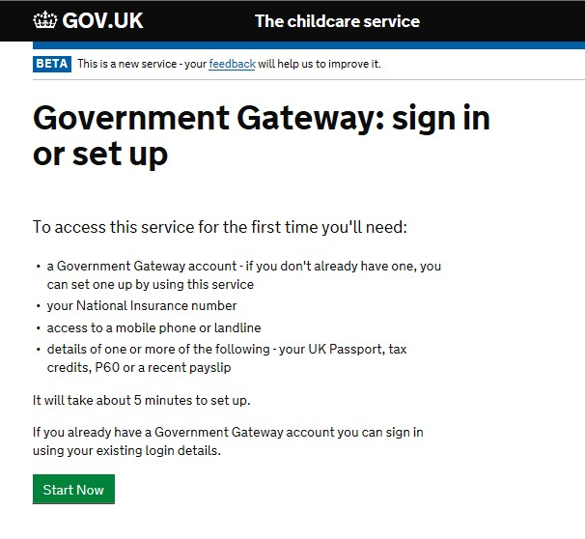

Step 7
Enter your Government Gateway User ID and Password and then click the green button labelled ‘Sign in’
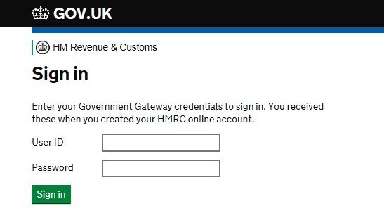

Step 8
Your childcare account will now be displayed. Click ’30 hours free childcare’ to see your 11 digit code, which usually starts with ‘5000…’
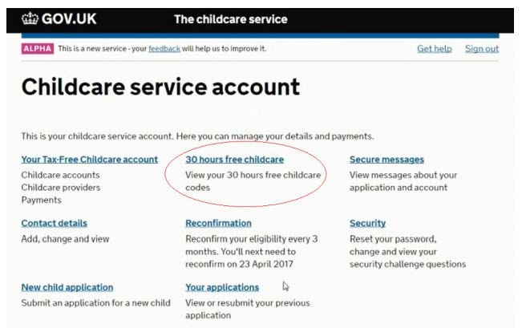

Or you can click on ‘Secure messages’ where you will see a message that looks like this (this would be populated with your information).
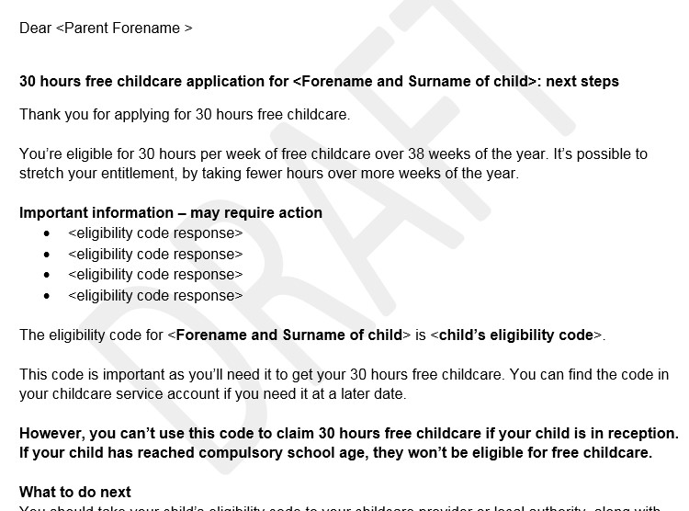

Please note that a small number of parents will have been issued with a temporary code which starts “11…” These will only have been issued over the phone by HMRC and parents will have received a letter containing this from HMRC too.
If you are still struggling to access your account, please contact HMRC’s call centre

on 0300 123 4097

