Draft Tees Valley Joint Waste Management Strategy for consultation

2020 to 2035

Contents
Contents 2
Introduction 1
Policy Context 1
How our Strategy has been developed/evolved 3
This Strategy Document 3
Waste Management in Tees Valley 5
Tees Valley 5
Council Waste Services 5
How much waste is produced in Tees Valley? 6
Waste Trends 7
Recycling and Composting Performance 7
Treatment and Disposal Performance 8
Our Vision for the Future – Sustainable Waste Management 9
Strategy Objectives and Targets 9
How Do We Achieve the Strategy Vision? 9
Waste Prevention, Reuse and Recycling Options 10
Recycling and Composting Collection Options 10
Residual Waste Treatment Options 11
Options Appraisal 11
The Preferred Option 11
Delivering the Preferred Option 12
Next Steps 13
Measuring Success 13
Glossary of Terms 14
Annex: Waste Management Data 15

Introduction
This document is the Joint Waste Management Strategy for Tees Valley. It has been produced by the five local councils that comprise Tees Valley: Darlington Borough Council, Hartlepool Borough Council, Middlesbrough Council, Redcar and Cleveland Borough Council, and Stockton-on-Tees Borough Council.
The strategy sets out the joint approach to the sustainable management of waste within the Tees Valley and prioritises actions for the next fifteen years. It provides the framework for how the councils will work towards reducing the amount of waste produced, to recycle as much material as possible and find the most sustainable solution to deal with any waste that remains.
In recent years the amount of waste produced in Tees Valley has remained relatively constant and the amount of waste sent to landfill has reduced. However, there has been no increase in the amount of waste recycled. Currently only 34% of the household waste produced is recycled. So, there is still much more to be done before recycling becomes second nature and the amount of waste everybody produces each year falls.

Policy Context
The way that waste is managed in Tees Valley has been shaped by both National and European policies that has evolved over time setting out targets for recycling, limits on landfill, and encouraging activity around waste prevention.
The UK’s decision to leave the European Union does create a degree of uncertainty over the future development and implementation of environmental policy and legislation, particularly over the next few years.
However, the 25-Year Environment Plan published by Defra in January 2018 makes a number of statements with regards to future environmental policy and legislation
In the Foreword, the Prime Minister states:
‘When the United Kingdom leaves the European Union, control of important areas of environmental policy will return to these shores. We will use this opportunity to strengthen and enhance the protections that our countryside, rivers, coastline and wildlife habitats enjoy, and develop new methods of agricultural and fisheries support which put the environment first.’
Further, in Section 2 on ‘Putting the Plan into practice’, it states:
‘The Plan coincides with the once-in-a-generation opportunity presented by our leaving the EU. We will make the most of the chance to improve our environmental policy framework, align it with the ambitious goals we have set, and lead from the front in pursuit of higher standards across the world.
The European Union (Withdrawal) Bill will ensure that the body of existing EU law, including environmental law, continues to hold sway in the UK. Key underlying principles of existing policy, such as the ‘polluter pays’ principle and the precautionary principle, are reflected in this legislation and in the historic judgements of the European Court, also covered by the Bill.
We will be consulting on the development of a policy statement on environmental principles to underpin policy-making post-EU Exit. This will provide maximum certainty about environmental regulations as we leave the EU.’
In addition, with regards to minimising waste, the 25-Year Plan makes the commitment:
‘meeting all existing waste targets – including those on landfill, reuse and recycling – and developing ambitious new future targets and milestones’.
A new Resources and Waste Strategy is expected to be published by Defra before the end of 2018. Defra’s stated ambition is for the UK to ‘become a world leader in resource efficiency, resource productivity and increasing competitiveness’.
This strategy and current national policy are based on the principle of the waste hierarchy (Figure 1). The waste hierarchy is an important approach in waste management and it presents a number of waste management stages in their order of priority. It stresses the importance of preventing waste being created in the first instance as the main priority and disposal as the lowest priority option. Producing recyclable material of a high quality is also important so that further treatment and disposal is minimised.
Alongside the waste hierarchy is the concept of the circular economy (Figure 2), in which:
- resources are kept in use for as long as possible;
- the maximum value is extracted from them whilst in use;
- products and materials are recovered and regenerated at the end of each service life.
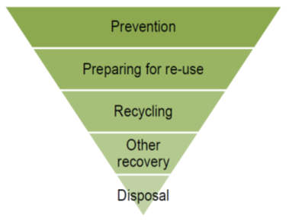
- Waste hierarchy
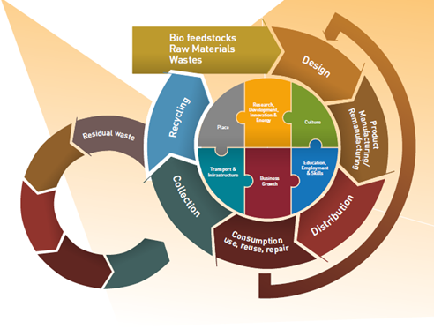
- Tees Valley Strategic Economic Plan 2016 – 2026 (Tees Valley Combined Authority)
To support the delivery of a circular economy the following targets have been agreed in Europe, which the UK are expected to adopt:
- 55% recycling target for municipal waste by 2025
- 60% recycling target for municipal waste by 2030
- 65% recycling target for municipal waste by 2035
- 10% limit on the landfilling of municipal waste by 2035

How our Strategy has been developed/evolved
In 2008 the Tees Valley councils produced a joint strategy for the wastes collected and managed by the councils. The principles of the 2008 strategy were:
- to reduce waste generation;
- to be achievable and affordable;
- to work towards zero landfill;
- to minimise the impact on climate change;
- to have an accountable and deliverable structure;
- to contribute towards economic regeneration.
This document considers the work that has been undertaken since the original JWMS was published in 2008 and reviews current performance. It also sets out the strategic objectives that are important to Tees Valley going forward and how it is proposed to support the changes required to meet these objectives.

This Strategy Document
This document covers the period from 2020 to 2035 and sets out Tees Valleys approach to the management of Local Authority Collected Waste (LACW) over this timeframe. The strategy will subsequently be supported by action plans for each council, which provide detail of individual activities at a local level.
It is intended to review the strategy on a five-yearly basis.
This strategy document has been developed alongside and supported by:
- an Options Appraisal which considers a number of different ways to achieve the objectives in this strategy; and
- A Strategic Environmental Assessment (SEA), which has been carried out to determine if the activities that are proposed to progress in Tees Valley are likely to have any significant adverse impact on the environment.

Waste Management in Tees Valley

Tees Valley
Tees Valley covers an area of 790 km² hectares and has a rich industrial heritage with an economy based around key sectors including advanced manufacturing and engineering, aerospace, automotive, chemicals and processing and offshore oil and gas.
The population of the area is approximately 670,000, averaging 2.3 inhabitants per household, with much of the population centred around the River Tees and Teesmouth.
As with many areas that had a strong historic industrial heritage, there is a high level of deprivation amongst the population, which the Tees Valley Councils and the Tees Valley Combined Authority are working to overcome. It is well known that this situation also presents challenges for the provision and operation of efficient waste management services in particular waste avoidance and high recycling rates.

Council Waste Services
Waste collection services are provided by each local authority through in house services teams.

Kerbside Collections
All councils offer a fortnightly dry recycling collection service, the principal materials collected are paper, card, cans, glass, and plastic bottles. Some councils also collecting plastic tubs, pots and trays and drinks cartons. These materials are either sorted at the kerbside or at a Materials Recovery Facility (MRF) and then sent to a variety of end markets for sale or further reprocessing.
Refuse is collected weekly in Middlesbrough and Stockton-on-Tees and fortnightly in Darlington, Hartlepool and Redcar and Cleveland.
Garden waste is collected free of charge fortnightly by all authorities, with the exception of Darlington where no service is currently provided.
None of the authorities collect food waste, either mixed with the garden waste or separately as a dedicated service, it remains in the residual waste.

Bulky Collections and Trade Waste
All Councils offer a charged bulky household waste collection for larger household items
Four of the five Tees Valley local authorities provide a trade waste service. In Middlesbrough businesses are directed to use suitable contracted services.

Household Waste Recycling Centres (HWRCs)
HWRCs are sites to which residents can take items that cannot be collected as they are either difficult or costly to collect from households, e.g. electrical items, household chemicals, furniture and rubble. There are currently four HWRCs across the Tees Valley, where residents can take household waste to be re-used, recycled or disposed of. Residents from each council have access to the HWRC in their home council area, with the exception of Middlesbrough where residents have access to the Haverton Hill HWRC (in Stockton-on-Tees), which is jointly managed by Middlesbrough and Stockton-on-Tees Councils.
A variety of materials are accepted for recycling at all of the HWRCs including wood, oil, batteries, paper, card, metals, textiles, glass, furniture, plastic bottles, garden waste and electrical equipment.

Treatment and Disposal
With the exception of Darlington, household residual waste is treated through an Energy from Waste (EfW) combustion facility at Billingham in Stockton-on-Tees. The residual waste collected from Darlington is currently treated through a residual waste MRF at Aycliffe Quarry, from where the Refuse Derived Fuel (RDF) produced is exported to an EU based EfW facility.

How much waste is produced in Tees Valley?
In 2016/2017 just over 350,000 tonnes of LACW was produced across Tees Valley. This tonnage is equivalent to approximately 1 tonne per household per annum (in 2016/17).
A summary of the total arisings in the Tees Valley is shown in Figure 3 , this covers the last 7 years and is colour coded by each Council’s contribution to total arisings. The actual tonnage data are provided in the Annex.
In addition to the waste collected by local authorities there remains a significant proportion of waste that is generated by commercial and industrial, construction and demolition activities, which is managed by private waste contractors. This is not dealt with by local authorities’ and is therefore not a focus of this strategy document.
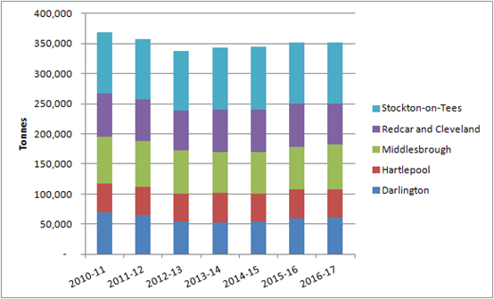
- Total LACW produced in the Tees Valley 2010-11 to 2016-17

Waste Trends
The amount of waste produced in 2016/17 can be compared with the tonnage produced since 2010/11. The tonnage data shows a decline up to 2012/13 followed by a steady increase back to the 2010/11 figure. Over this time waste trends have tended to mirror patterns of economic decline and growth.
There are, however, other factors that influenced these figures including housing growth, local authority waste prevention activities and weather conditions (which has an impact on the amounts of garden waste produced). Overall since 2012/13, at the Tees Valley level, the waste produced per household has remained relatively static just below 1 tonne per household per year. At the individual council level, Darlington, Hartlepool and Stockton-on-Tees have seen small deceases whilst Middlesbrough and Redcar and Cleveland experiencing small increases.
Looking forward, across all the council areas population and housing is predicted to increase to 2035. These predicted increases in population and housing means that more waste is likely to be generated across the Tees Valley area, which will also need to be managed.
A range of waste growth scenarios have been considered based on local and national trends. The resulting waste forecasts indicate that between 373,000 to 399,00 tonnes of LACW (Figure 4) will be produced by 2035 compared to the 352,000 tonnes produced in 2016/17. If the economic regeneration planned by the Tees Valley Combined Authority is realised, this could increase population and housing further resulting in between 392,00 to 420,00 tonnes of LACW by 2035.
For the purposes of waste strategy planning it has been assumed that the future waste growth rate will be approximately 0.25% per annum.
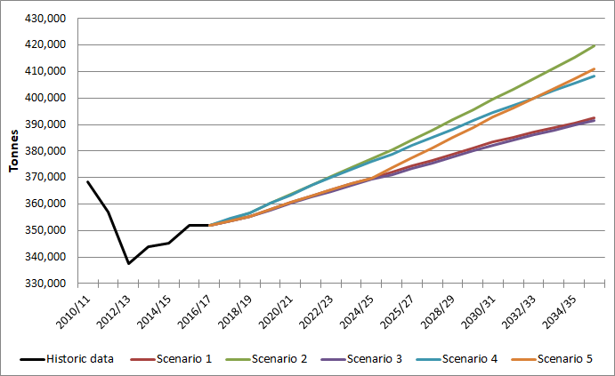
- Range of forecast tonnages up to 2035

Recycling and Composting Performance
Over the last seven years there has been little change in the quantity of material collected for recycling and composting across Tees Valley. In 2016/17, the combined household waste recycling rate for the Tees Valley Councils was 34%.
Figure 5 shows the household recycling rates between 2010/11 and 2016/17 for England, the North East region and the combined rate for the Tees Valley Councils. The figure highlights that whilst the performance in Tees Valley is below the national average, the trend is consistent with national performance with household recycling rates remaining relatively static.
In addition, the household recycling rates in Tees Valley are comparable with those achieved across the North East region.
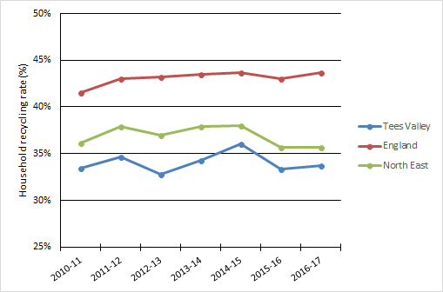
- Household recycling rates for Tees Valley, England and the North East region

Treatment and Disposal Performance
Whilst recycling performance has not changed over recent years, there has been a notable improvement in the recovery of LACW and its diversion from landfill.
Figure 6 shows that since 2010/11 there has been:
- a 13% increase in the amount of waste recovered through energy recovery;
- a 10% reduction in the amount of waste sent to landfill
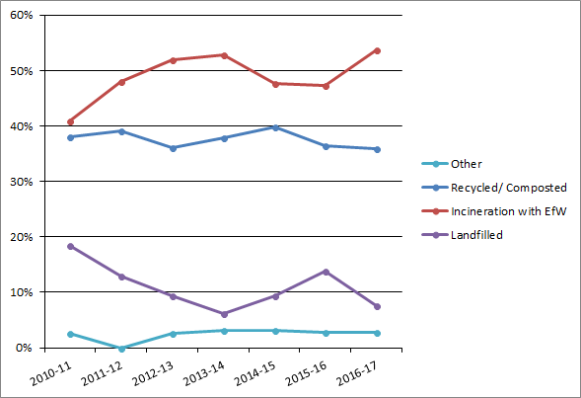
- Tees Valley LACW Management Methods 2010/11 to 2016/17

Our Vision for the Future – Sustainable Waste Management
The Tees Valley Joint Waste Management Strategy aims to deliver a high quality, accessible and affordable waste management service that contributes to:
- economic regeneration, including employment and a more circular economy;
- the protection of the environment and natural resources; and
- reducing the carbon impact of waste management.
and:
- delivers customer satisfaction;
- reduces the amount of waste generated by householders and the Councils;
- increases reuse and recycling;
- then maximises recovery of waste, and;
- works towards zero waste to landfill.
The Tees Valley Councils, acting in partnership, are committed to working towards this vision for waste management. This includes supporting the necessary changes in behaviour and practice whilst at the same time balancing financial commitments and budgets to provide a high-quality service supporting local self-sufficiency.

Strategy Objectives
Over the period of the strategy the Tees Valley Councils will seek to achieve the following objectives, always recognising the challenges of delivering increasing levels of high quality recycling efficiently and economically and support from central Government:

Waste generation:
- Aim to maintain the current level of below 1 tonne of household waste per household.

Reuse and recycling:
Increase reuse, recycling and composting of household waste from the current levels to:
- 45% to 50% in the first five year of this strategy (2020 to 2025);
- between 2025 and 2030 seek to further improve reuse, recycling and composting beyond the 2025 levels;
- set targets for beyond 2030 during the strategy review in 2025.

Waste recovery and landfill diversion:
- provide sufficient waste recovery capacity to ensure that no more than 10% of LACW waste is landfilled.

How Do We Achieve the Strategy Vision?
To achieve the strategy for waste management in Tees Valley all parties and stakeholders will need to work together; this means all residents participating and contributing, supported by initiatives from the Tees Valley Councils. There are many different actions that can be taken to support the strategy and produce a visible change. Education will be key in changing attitudes and behaviour and thus improving performance against the objectives and targets.
A wide range of options across the waste hierarchy have been considered, with different combination of the following options being testing through an options appraisal.

Waste Prevention, Reuse and Recycling Options
Raising waste awareness and education campaigns | Various campaigns designed to raise awareness and increase participation in waste prevention and reuse activities, including:  - general education and waste prevention initiatives;  - general reuse initiatives  - Love Food Hate Waste  - Junk Mail  - promoting smart shopping practices
Home Composting / Digestion | Promote home composting (or anaerobic digestion) to reduce the demand on collection services and treatment capacity
Reuse at HWRCs | Install facilities at HWRCs that allow members of the public to leave and collect items such as furniture, including awareness and promotional campaigns of the service.
Bulky Collection Reuse | Sorting of bulky waste collections to extract reusable goods with a view to refurbishment, reuse and resale, including awareness and promotional campaigns.

Recycling and Composting Collection Options
High efficiency scenario | Which would look at increasing dry recycling performance, through a reduction in residual waste collection capacity and introducing a charge for garden waste services
High recycling performance scenario | Which would look at increasing dry recycling performance through introducing separate food waste collections, reducing residual waste collection capacity and introducing a charge for garden waste services
Alongside these primary options:
Bulky Waste Recycling | Sorting of bulky waste collections to extract recyclable goods in order to improve recycling performance, including awareness and promotional campaigns of the services provided.
Quality: Reducing contamination in recycling/composting | Stronger engagement with residents to increase public understanding of the issues associated with contamination of recycling/composting collections to deliver behaviour change. Combined with tighter management of contamination across all Tees Valley councils.

Residual Waste Treatment Options
The primary waste treatment option at the Tees Valley level:
- Further contract extension (beyond 2025) for the existing EfW contract
- New build energy recovery facility
- New build refuse derived fuel facility (RDF)
- Utilise third party energy recovery facility capacity

Options Appraisal
Twenty combinations of these options were considered against the following criteria:
- Delivers an accessible service with engagement and customer satisfaction
- Reduces the amount of waste generated by householder and managed by the Councils from baseline forecast
- Increases reuse and recycling
- Maximises recovery of waste
- Working towards zero waste to landfill
- Economic regeneration, including employment and a more circular economy
- Protection of the environment and natural resources
- Reducing the carbon impact of waste management
- Affordable (long term measure)
- Deliverability
Full details of the assessment are included in the Options Appraisal Report.

The Preferred Option
The Options Appraisal process identified the following preferred option:
- adoption of prevention, reuse and recycling initiatives;
- the introduction of high recycling collections including separate food waste collections; and
- a new energy recovery facility with the ability to utilise the heat produced, through the development of Combined Heat and Power (CHP).
The Preferred Option would:
- Contribute to reducing the amount of waste generated compared to the baseline forecast;
- Increase the recycling and composting rate by 13-14% by the midpoint of the Strategy period (2027) to bring the overall recycling and composting rate to between 45-50%. This is a significant improvement on the current performance and reflects the challenges faced in an urban industrial setting;
- Further increase the recovery of waste by 3-4%;
- Further reduce the waste sent to landfill;
- Reduce the carbon impact of waste management; and
- Create/secure employment within Tees Valley.

Delivering the Preferred Option
The 2008 JWMS set out a series of policies to support the implementation of the strategy. These existing policies are still valid and consistent with the refreshed strategy aims and objectives.
Therefore, the existing policies are to be retained to help each Council develop local solutions against a consistent policy framework.

Policy 1: Joint Working
We will continue to work together in partnership with other stakeholders in order to ensure sustainable waste management within the Tees Valley to protect the natural environment. We will strive for sub-regional self-sufficiency and be mindful of the proximity principle.

Policy 2: Sustainable Waste Management
We will ensure that the services delivered by the Tees Valley Authorities implement methods of sustainable waste management in line with the Waste Hierarchy.

Policy 3: Waste Awareness and Prevention
We will work with partners to promote waste awareness and prevention and encourage householders, schools and local businesses to reduce the impact of their behaviour with regards to their waste stream.

Policy 4: Waste Collections
We will increase the proportion of material that is collected for recycling and composting through kerbside schemes, bring sites and HWRCs.

Policy 5: Waste Treatment Facilities
We will maximise the amount of material that is recycled, composted or recovered from the residual waste stream.

Policy 6: Residual Waste Stream
We will minimise the amount of waste that is disposed of in line with our principle of working towards zero waste to landfill.

Policy 7: Monitoring and Review
We will regularly monitor and review this Strategy in consultation with stakeholders and the public to ensure that it links with other plans and strategies.

Next Steps
This overarching Strategy document provides a framework for action in Tees Valley.
Following the adoption of the overarching Strategy, each of the Tees Valley Councils will develop an individual action plan to tailor the delivery of the preferred option to complement their current services and reflect their specific local circumstances and operations.

Measuring Success
There are several ways in which success can be measured and progress against the strategy can be determined.
The performance of the JWMS will be monitored against the following performance measures.
Performance measures | Unit/metric
Waste generation: | Waste generated per household per year
Reuse and recycling | % of waste recycled per year
Waste recovery and landfill diversion | % of waste landfilled per year
The Strategy will be reviewed every five years. Progress on delivery of this Strategy will be regularly reported.

Glossary of Terms
AD | Anaerobic Digestion
AQMA | Air Quality Management Area
BAP | Biodiversity Action Plan
CH₄ | Methane
CHP | Combined Heat and Power
CO₂ | Carbon dioxide
DCLG | Department of Communities and Local Government
DECC | Department of Energy and Climate Change
DEFRA | Department for Environment, Food and Rural Affairs
EA | Environment Agency
EU ETS | EU Emission Trading System
TVJWMS | Tees Valley Joint Municipal Waste Management Strategy
GHG | Greenhouse Gases
GWP | Global Warming Potential
HPA | Health Protection Agency
HWRC | Household Waste Recycling Centre
JWMS | Joint Municipal Waste Management Strategy
LACW | Local Authority Collected Waste
LATS | Landfill Allowance Trading Scheme
MRF | Materials Recovery Facility
N₂O | Nitrous Oxide
PO₄ | Phosphates
RDF | Refuse Derived Fuel
SEA | Strategic Environmental Assessment
SO₂ | Sulphur Dioxide
SPA’s | Special Protection Area’s
SPZ’s | Source Protection Zones
SSSI | Site of Special Scientific Interest
WEEE | Waste Electrical and Electronic Equipment
WRAP | Waste and Resources Action Programme
WRATE | Waste and Resources Assessment Tool for the Environment

Annex: Waste Management Data

Total LACW arisings in the Tees Valley 2010-11 to 2016-17
Authority | Tonnes of LACW
 | 2010-11 | 2011-12 | 2012-13 | 2013-14 | 2014-15 | 2015-16 | 2016-17
Darlington | 68,880 | 65,009 | 53,809 | 53,215 | 54,255 | 60,221 | 61,115
Hartlepool | 48,995 | 46,951 | 46,456 | 48,394 | 46,985 | 46,914 | 46,524
Middlesbrough | 76,858 | 75,417 | 71,817 | 68,235 | 67,888 | 71,364 | 74,399
Redcar and Cleveland | 71,715 | 69,537 | 66,462 | 70,384 | 71,804 | 70,995 | 67,612
Stockton-on-Tees | 101,997 | 99,983 | 99,121 | 103,582 | 104,218 | 102,613 | 102,466
Tees Valley | 368,444 | 356,897 | 337,664 | 343,809 | 345,150 | 352,107 | 352,116
Source: Department for Environment, Food & Rural Affairs

Management of LACW in the Tees Valley 2010-11 to 2016-17
Authority | Management of LACW (tonnes and %)³
 | 2010-11 | 2011-12 | 2012-13 | 2013-14 | 2014-15 | 2015-16 | 2016-17
Recycled/ Composted | 138,616 | 139,754 | 121,598 | 130,009 | 137,252 | 127,986 | 126,369
 | 38% | 39% | 36% | 38% | 40% | 36% | 36%
Incineration with EfW | 149,359 | 171,063 | 175,456 | 181,777 | 164,675 | 166,280 | 188,870
 | 41% | 48% | 52% | 53% | 48% | 47% | 54%
Incineration without EfW | 7 | 8 | 5 | 5 | 6 | 24 | 5
 | 0% | 0% | 0% | 0% | 0% | 0% | 0%
Landfilled | 67,056 | 46,078 | 31,560 | 21,116 | 32,514 | 48,331 | 26,956
 | 18% | 13% | 9% | 6% | 9% | 14% | 8%
Other¹ | 9,699 | - | 9,037 | 10,904 | 10,706 | 9,482 | 9,909
 | 3% | 0% | 3% | 3% | 3% | 3% | 3%
Total² | 364,737 | 356,902 | 337,656 | 343,811 | 345,151 | 352,103 | 352,108
Notes:
- Other includes waste treated/disposed through other unspecified treatment processes as well as process and moisture loss.
- Total Local Authority collected waste managed may not match total Local Authority collected waste arisings due to stockpiling of waste between reporting periods.
- Inputs to intermediate plants e.g. MBT, Residual MRFs, RDF and other plants prior to treatment and disposal and included in the final treatment and disposal figures.
Source: Department for Environment, Food & Rural Affairs

EU targets as well as UK
Municipal waste consists of the wastes collected and managed by local authorities (known as Local Authority Collected Waste (LACW)) and similar commercial and industrial wastes.
Waste collected by the councils from commercial properties

