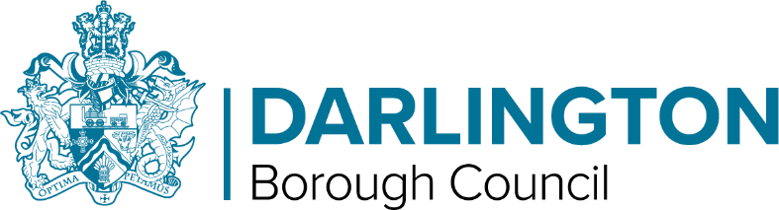 | PEOPLE GROUP  Children’s Division  Town Hall, Darlington DL1 5QT
07827 937428
Jamie.wassell@darlington.gov.uk
25 October 2023

YOUNG DARLINGTON ADVISOR - EXPRESSION OF INTEREST

Post applied for | Young Darlington Advisor (YDA)
Service area of post applied for | Youth Participation, Darlington Borough Council

Section 1 – Personal Details
Name: | Contact Number:
Address:

Date of Birth: | Age:  (must be between 13 to 19 & up 25 for care leavers or those with an EHCP or SEN support)
Email address:
Preferred method of communication:

Section 2 – Supporting Information
Please can you tell us about your skills, knowledge and experiences that make you suitable for this post and why you would like to be a YDA.

Section 3 – People with disabilities
Do you require any special aids/equipment or assistance with the interview? Yes/No
If yes please provide details below;

Section 4 – Declaration
I certify that the details provided are, to the best of my knowledge and belief, accurate.
Full name
Signature
Date

Section 5 – Parental Consent
Please ensure you have discussed this application with those that care for you so they are happy for you to commit your time and energy to the project and are happy that there will be no detrimental effect to your education.
Full name
Signature
Date

Completed expression of interest forms must be submitted by Friday 9th February to Jamie.wassell@darlington.gov.uk

