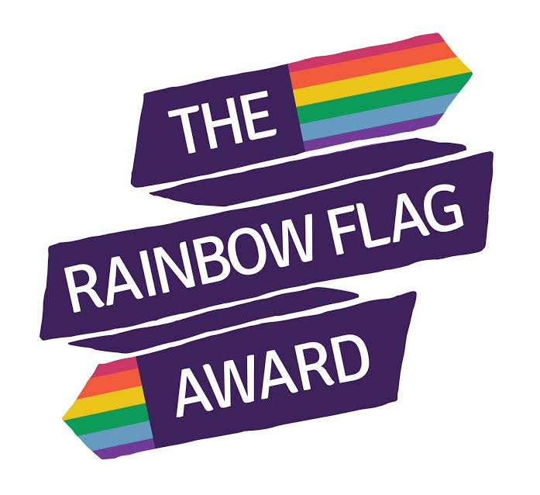
Rainbow Flag Award
Application Form
Apply electronically at: theproudtrust.org/rainbow-flag-award

Schools will be selected based on:
1. If they have done little or nothing by way of addressing homophobia, biphobia or transphobia (HBT) in the school.
2. Whether the school can commit to the project and the ethos of challenging HBT bullying.
The final stage is internal selection, where we will aim to have a portfolio of geographies/types of school/demographics of pupils.

Name of School:

We are a: Primary school State funded

Secondary school Academy

SEND/Alternative school Private

School Address:

School website address:

Which local authority do you fall under?

Lead person for this project: Job Role:

Email address: Phone number:

Taking part in this project requires you to agree to a pre and post evaluation process (with pupils and staff) with an independent evaluator provided by the Government Equalities Office:
I agree

What have been the blocks or challenges that have prevented you from doing work that addresses homophobic/biphobic/transphobic (HBT) bullying in the past?
Why are you applying for your schools to take part in the Rainbow Flag Award and why should we select you?
What have been the blocks or challenges that have prevented you from doing positive education around about LGBT (lesbian, gay, bisexual, trans) identities in the past?

Are there any particular issues or areas that you feel would need addressing as part of this process?

Please return completed forms to:
Billijean Summerbell, Aycliffe Business Park, Unit 2, Sapphire House, Horndale Avenue, Newton Aycliffe, DL5 6DS

