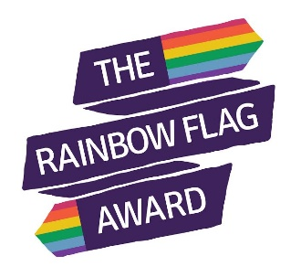**Rainbow Flag Award - Project Timeline**

**Autumn Term 2016**

Schools – primary and secondary- apply to take part in the project.





**Rainbow Flag Award attained**

**Schools Implement LGBT Inclusion**

Schools may use their remaining credits to help embed LGBT inclusion into their schools across the six Rainbow Flag areas. Credits can be used in the way most useful to schools.

**Compulsory module: Inclusive Policy Training** – yellow section (2 credits per attendee):

* Autumn term 2017
* Summer term 2018
* Autumn term 2018
* Spring term 2019

Ongoing desk top reviews of Rainbow Flag quality assurance using self -assessment tools. Outcomes and improvement plans provided.

**LGBT Inclusion in Education Training**

Teacher training will happen in waves to begin a school on their journey (compulsory):

* Spring term 2017 (20 schools)
* Summer term 2017 (65 schools)
* Autumn term 2017 (55 schools)
* Spring term 2018 (76 schools)
* Autumn term 2018 (34 schools)

Schools that subsequently demonstrate cascading the learning about LGBT Inclusion good practice within their schools will gain the red section – “Skilled Teacher” award.

Schools complete a self-assessment following training. This will determine which are put forward for the whole school approach and begin the Rainbow Flag Award – six sections.

Successful schools awarded credits (28 minus 2 for each LGBT Inclusion training attendee).

**Spring Term 2017**

Selection process takes place, successful schools sign a confirmation agreement.