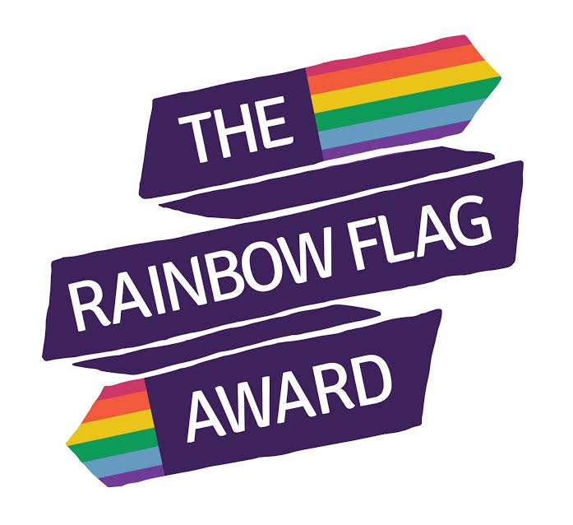
October 2016
Dear
I am writing to share some very exciting news. Recently The LGBT Service at DISC (alongside our partner organisations SexYOUality in Cambridgeshire, Allsorts in Sussex and The Proud Trust in the North West) was successful in a funding bid from the Government Equalities Office, via the Department for Education. The grant is to fund initiatives that will enable schools to effectively combat and prevent homophobic, biphobic and transphobic (HBT) bullying, we are very proud to announce the launch of The Rainbow Flag Award.
The Rainbow Flag Award will encourage a whole school approach to tackling HBT bullying and LGBT (lesbian, gay, bisexual, trans) inclusion, focusing on the following areas:
Red – Skilled Teachers
Orange – Supportive Governors and Parents
Yellow – Effective Policies
Green – Inclusive Curriculum
Blue – Pastoral Support
Violet – Pupil Voice
We are looking for schools – primary and secondary – to take part in this pioneering new project. Two hundred schools that are successful in the initial application process will receive free LGBT inclusion training, which can subsequently lead them to gaining the “Skilled Teacher” red section of the award.
Following initial LGBT inclusion training, a self-assessment will be completed and one hundred schools will then go forward to gain the full award – see enclosed timeline.
Schools that complete the Rainbow Flag Award will have done so with up to £1400 of free training, resources and initiatives.
Taking part in this project will help you meet:
- Your legal requirement to ensure LGBT inclusion in schools;
- The Ofsted requirement for you to be effective in tackling HBT bullying;
- Your moral requirement to meet the needs of LGBT young people, given the wealth of evidence showing that LGBT young people are still disproportionally affected by mental health issues and teen suicide.
To apply to take part in the project, please fill in the enclosed form

Closing date for applications is Friday 2 December 2016 at 5pm.
We look forward to working with you.
Billijean Summerbell/ Jo Dixon
Project Lead/ Project Worker
The LGBT Service DISC
lgbt@disc-vol.org.uk 01325 731160

