[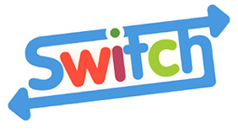](http://www.switchdarlington.co.uk/)

**OTHER USEFUL NUMBERS ADDITIONAL INFORMATION**

**The National Youth**

**Advocacy Service**

**(NYAS):**

0808 808 1001

[help@nyas.net](mailto:help@nyas.net)

**One Stop Shop:**

01325 406170

**Child Line:**

0800 1111

**Counselling Centre**

Rape/Sexual abuse

Support line:

01325 369933

Business line

01325 354119

**FRANK:**

0800 77 66 00

www.talktofrank.com

Young people and professionals can access

and refer into the team through the confidential

 SWITCH e-mail address: [switch@neca.co.uk](mailto:switch@neca.co.uk)

Secure email:  [switch.darlington@neca.cjsm.net](mailto:switch.darlington@neca.cjsm.net)

Professionals will need to complete a Switch

referral form.

If you require any further information please

contact the Switch team:

**The Gate**

**John Dobbin Road**

**158-166 Northgate**

**Darlington**

**DL1 1QU**

**THE YOUNG PEOPLE’S**

**Confidential ALCOHOL, DRUG**

**AND SOLVENT**

**MISUSE TEAM**

**Tel: (01325) 267 230**

**Fax: (01325) 243 377**

**switch@neca.co.uk**

**www.switch.neca.co.uk**



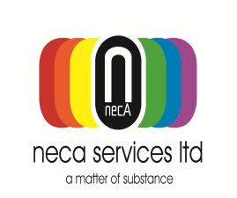 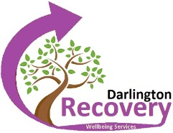

Registered Charity No. 516516

**[](http://www.switchdarlington.co.uk/)WHAT IS** ?

We are a team of drug and alcohol workers

working with young people aged 10 - 18 years.

We provide an holistic, individual and flexible

approach to young people experiencing problems with substance misuse.[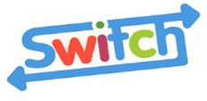](http://www.switchdarlington.co.uk/)

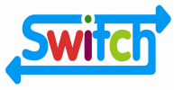

**CAN OFFER**

• Alcohol, drug and solvent misuse advice and

information on how to stop using, reduce use

and minimise the risks

• Positive activities linked to other young

peoples services i.e. Youth Service, Connexions

• Hepatitis A & B vaccinations

• Blood borne virus testing

• Chlamydia testing

• C. Card

• Harm minimisation

• Counselling service.

 Who is for?

Individuals who have one or more of these

problems:

• Experiencing problems as a result of alcohol, drug or solvent use

• Having problems stopping or cutting down

their alcohol, drug or solvent use

• Needing to use alcohol, drugs or solvents to

feel ‘normal’

• Needing to take drugs to get through the day

• Injecting drugs

• Spending most of their time drinking, taking

drugs or trying to get hold of them.

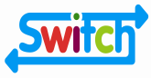

HOW DOES WORK?

• Young people can be referred to Switch by

anyone - professionals, parents, carers or

even themselves

• A choice of appointment, time and place will

be discussed and family and friends are welcome to attend appointments if you wish.

• Confidentiality is explained and agreed on the

first appointment

• A keyworker will be allocated

• An individual care plan will be agreed

• Everything will be discussed, planned and

agreed with the young person.

WHAT IS EXPECTED FROM THE YOUNG PERSON?

• That they attend Switch appointments

• That they want to find out about, change or

stop their alcohol, drug or solvent use.

SUPPORT AND ADVICE

Switch works closely with other services which offer support for young people who are at risk of having difficulties with substance misuse. We also offers support for parents and carers if appropriate.

Multi-agency working ensures that individuals

are provided with the right services to meet their needs.

Other services can be contacted for advice,

information and support around alcohol, drug and solvent use.