|  |
| --- |
| Community LIBRARIES steering group on behalf of Darlington for culture |
| The Future of Darlington Libraries |
| Business Case |
|  |
|  |
|  |

24/05/2016

|  |
| --- |
|  |

|  |
| --- |
| Darlington Borough Council (DBC) is having to make difficult decisions in the face of significant reductions to government funding. This Business Case examines the options put forward by DBC for the future of the library service. It identifies a number of additional costs not included in the suggested saving of £335,000 from moving Crown Street library service to the Dolphin Centre, and indicates that in comparison to the council’s own alternative option of remaining at Crown Street the saving is potentially only in the region of £102,000 per annum, with a number of significant risks and potential additional costs. The difference may be even smaller if the estimated capital cost of remaining at Crown Street is not as high as the suggested £800,000. This business case also examines a third option, put forward by the community, whereby a Charitable Incorporated Organisation is set up, to take on running both Crown Street and Cockerton premises. Both buildings would become Community Hubs, offering a range of facilities and services, generating an income to help cover premises costs. They would also incorporate library services that would continue to be operated by DBC. This option also offers the potential to retain some of the current mobile library service, and have an additional “Quick Picks” satellite site at the Dolphin Centre. This third option has the potential to deliver greater financial savings than the DBC proposal, whilst also providing many other benefits to the community. In particular it offers the potential to increase library use, and importantly would enable the community to retain a much loved heritage building that was gifted to the people of Darlington. It would also give more time to explore alternative revenue generating options for the space that DBC has shown can be created at the Dolphin Centre. |

Contents

1. Document Purpose 2

2. Background 2

3. Solution 3

4. Options 3

4.1. Council Options 3

4.1.1. Option 1 3

4.1.2. Option 2 6

4.2. Community Alternative Option 7

4.2.1. Option 3 7

5. Approach 8

6. Risks and Mitigation 9

7. Benefits 10

7.1. Tangible 10

7.2. Intangible 11

# Document Purpose

The purpose of this document is to outline an alternative option for Darlington Library Service to that presented by Darlington Borough Council (DBC). It also seeks to present the full costs of each option to ensure a decision can be reached on consideration of the full facts. The document is as a result of considerable involvement from the community on what they would like to see for the future of Darlington Libraries, facilitated by Darlington for Culture, and is also based on industry research.

# Background

In February 2016 DBC outlined a range of proposals as part of its process of setting its budget for 2016/17 to 2019/20. The cuts included significant cuts to the Library service which is currently offered in Darlington, the proposal was to:

* Relocate Crown Street library to the Dolphin Centre
* Close Cockerton Library
* Cease the mobile library service

Since the announcement was made many residents have shown their support to save Crown Street library:

* Almost 1000 people protested outside the library on 26 March
* Almost 1000 people have joined the Facebook page – Darlington Library Keep it in Crown Street
* A significant number of people have signed the Northern Echo coupon asking the Council to give more time for ways to keep the Library in Crown Street.
* Darlington for Culture has brought together groups interested in putting forward plans to keep Crown Street to try and find a workable plan that people can unite behind and the Council will accept
* A Friends of Darlington Libraries group has been formed

Not only has this activity shown how important the library is to the residents of the Darlington, it has also brought the community together, with people of all ages and walks of like taking part.

Crown street library is a Grade II Listed Building and was donated to the town by Edward Pease, specifically for ‘the education of the people of Darlington’. Covenant to the Deeds states the Building and Land must be used as a Library forever.

# Solution

Our proposed solution is to set up a Charitable Incorporated Organisation (CIO), to run the library buildings, and potentially the mobile library, whilst the Library Service, including local studies, continues to be provided by DBC, within the existing premises. The CIO would offer additional services within Crown Street and Cockerton libraries, turning them into Community Hubs, to enable them to generate income, and also increase use of the library services. The income generated would be used towards the upkeep of the buildings allowing the Library service to remain at Crown Street in line with the legacy left by Edward Pease, and allowing Cockerton Library, and potentially the mobile library, to continue, as the impact assessment is likely to show certain groups would be significantly affected were these to close. We also propose consideration is given to a new Quick Picks library satellite site at the Dolphin Centre, operated with a self service machine, to extend availability of books outside of current opening hours.

# Options

## Council Options

### Option 1

Closure of Cockerton and Mobile Libraries, and relocation of Main Library and the following services to the Dolphin Centre:

* Lending Library
* Children’s Library
* Reference Library
* Centre for Local Studies
* Library Events
* ICT Facilities

DBC states relocation of the library will deliver the following benefits:

* Sustainable Library Service and Dolphin Centre
* Improved baby changing facilities
* Improved toilet provision
* Further develop the family learning experience
* Café
* Social space
* Expand a number of programmes, particularly for
* Children and young people
* Updated ICT provision
* Improved access and facilities for all residents
* Extended opening hours

#### Potential Savings

The following savings have been identified relating to Option 1

* + - Staffing £220,000
    - Supplies and Services (including books) £60,000
    - Building costs £120,000
    - Total = £400,000
    - Less financing for refurbishment £73,000  
       (includes financing for registry office relocation)
    - Less opportunity cost of current meeting room revenue £12,000
    - Less opportunity cost of space vacated by Registry Office £20,000
    - Less storage (e.g. DAD) £20,000

Total saving = £275,000 (reduced to £205,000 in Year 1 and potentially beyond)

This total saving is lower than the original DBC estimated saving of £335k per annum, as it takes account other relevant costs that have not previously been taken into account, around opportunity costs and storage costs. It is reduced further in Year 1, as £70,000 has been built into the budget for security / maintenance of Crown Street when it becomes empty.

The cost of financing includes an additional £140,000 for the relocation of the Registry Office.

There may be additional income in relation to secondary sales at the Dolphin Centre that have not been included, but these could also potentially be generated if other services were put into the space that the library would have gone into, thus generating increased footfall, so these would equally apply to all options.

*Note: savings against all options are in addition to the proposed savings from Cockerton and the Mobile Library which are consistent across all options unless otherwise stated.*

#### Risks

The following risks have been identified and would need to be explored by DBC:

* As the Covenant to the Deeds states the Building and Land must be used as a Library forever, DBC are likely to find it difficult to sell the building, this will leave the building empty and still in need of maintenance and potentially the additional costs of security to prevent break-ins and vandalism (estimated by DBC at £70,000 per annum), the longer the building takes to sell, the more these cost are likely to increase, whilst the value of the building depreciates. There may also be significant costs involved in removing the covenant, particularly as there are likely to be a number of objectors. This could run into the tens, or even hundreds of thousand pounds.
* The area proposed in the dolphin centre is located close to the children’s soft play area and below the fit lab classes, this could result in difficulties finding any quiet areas, eg for study. If further sound proofing does not work, and users complain, it may become necessary to cancel the fitlab classes which would pose a significant loss of income. Fitlab currently runs 35 classes per week from the Dolphin Centre.
* Relocation to the Dolphin centre does not guarantee an increase in footfall to the library and may put off older residents some of whom go to the library because of the beauty and heritage of the existing building.
* No clear solution yet apparent for the storage of the archives and collection.
* Potential loss of income and customer satisfaction at the Dolphin Centre whilst the works are undertaken.
* Risk of overspend on the capital estimates. Also further clarity is required on whether all relevant costs relating to the move have been considered and included in the capital estimates of £1.1million.
* Risk of additional money needing to be spent on Crown Street / Cockerton in order to prepare them for sale.

Other Concerns around Option 1:

### Option 2

Closure of Cockerton and Mobile Libraries, but the main library remaining at Crown Street, with refurbishment including a cafe.

Many of the benefits from Option 1 could potentially also apply following refurbishment, including:

* Improved baby changing facilities
* Improved toilet provision
* Further develop the family learning experience
* Café
* Social space
* Expand a number of programmes, particularly for
* Children and young people
* Updated ICT provision

#### Potential Savings

The following savings have been identified relating to Option 2

* + - Staffing £150,000
    - Supplies and Services (including books) £60,000
    - Building costs – zero
    - Additional Income from Cafe £10,000 (DBC estimate)
    - Less financing for refurbishment £47,000

Total = £173,000

This saving is £102,000 less than the saving identified in Option 1.

*Note: the financing for refurbishment is based on a spend of £800,000. Further work is needed to understand what this covers, and how much is essential work to be done in the short term, or what could potentially wait. Eg if only £200,000 worth of work needs to be done immediately, this would reduce the financing to £12,000 per annum, giving an overall saving of £208,000. This is only £67,000 less than the saving in Option 1, with potentially fewer risks.*

#### Risks

The following risks have been identified and would need to be explored by DBC:

* If nothing is changed then user numbers may continue to decline.
* If sufficient savings are not generated from elsewhere, other services provided for in the budget may be affected.

## Community Alternative Option

### Option 3

To retain the existing Libraries at Crown Street, and at Cockerton, and re-design the spaces to become well-equipped community hubs which can be used to offer a range of free and chargeable services. These would in turn increase footfall, resulting in both an increase in library useage, and also sufficient income generation to sustain the buildings.

The following services and facilities would be available at Crown Street which are aimed at satisfying the needs of multiple users:

Cockerton Library could potentially incorporate a small cafe, and would be redesigned to enable the space to be used for a variety of groups and events. Further detail on plans for Cockerton is contained in appendix 5.

Consideration would be given to Sunday opening at Crown Street as research suggests Sundays are one of the most profitable days for Cafes, so the additional cafe income could cover the extra costs of opening. A Quick Pick at the Dolphin Centre could also increase opening hours.

Income generation for Crown Street is predicted to be as follows:



It is also predicted that sufficient income could be generated at Cockerton to cover premises costs – see appendix 5.

# Approach

A Charitable Incorporated Organisation (or similar, depending on the most appropriate charitable trust model) would be set up, with Trustees from the local community (8 individuals have already committed to do this, with expertise covering a wide range, including events management, legal expertise, service improvement, library expertise, charity management). This charitable organisation would also be supported by a Friends of Darlington Libraries Group, giving access to keen volunteers, and would seek to contract with other local experts around buildings management, setting up and running cafes, and income generation, to learn from what has worked well elsewhere. Appendix 7 gives examples of successful local community trusts. These highlight the significant potential for increasing footfall, and therefore potential library service users.

Once up and running the CIO would apply for grants for further upgrade and refurbishment of the building and facilities.

Innovative approaches to attracting new customers / service users would be taken, eg offering loyalty membership discounts on room hire, student cafe discounts, offering work experience for college students, and offering free room hire to target groups, eg schools and pre-schools.

# Risks and Mitigation

The following risks have been identified and suggestions made for how they could be mitigated.

* The CIO fails to manage the buildings successfully, and they have to be taken back into DBC management.

This would be mitigated by having a skilled board of Trustees, by taking expert advice from Locality, and also by partnering with other organisation locally that have successfully set up and run community trusts / CIO’s.

The worst case would mean DBC having to resort to Option 2, which is £102k per annum worse than DBC Option 1. Although there would also be opportunity for DBC to generate additional income from the space in the Dolphin Centre, so this could also mitigate against the potential shortfall.

* The CIO fails to generate sufficient income.

This would be mitigated by looking at a range of other potential income generation streams not currently built into the proposed income figures.

If this still did not generate sufficient income, the options would either be for DBC to make up the shortfall, or worst case would be as above, resorting to Option 2.

* Lack of clarity around each parties responsibility and commitment

Contractual agreements would have to be in place to ensure clarity on DBC commitment in terms of library service provision, and also agreements around any space sharing, and amount of space allocated to each party, and responsibilities around buildings and services etc.

* Unanticipated problems arise with the buildings

Structural surveys need to be conducted, and funding applied for / fundraising activities undertaken, to bring the buildings into a good state of repair. A buildings fund should be made available to draw upon as and when necessary.

Other things that would need to be investigated and fully understood include:

* Understanding the extent of the investment deficit of the buildings – what is the current condition
* Agreeing at what point the buildings would be taken on – perhaps staggered
* Understanding if there are any staff that TUPE would apply to?
* Understanding what the proposed staffing level reductions would mean for the service.
* DBC library commitment – staffing levels and length (? 5 years, but with a get-out clause for DBC after 3 years?)
* ICT agreement – potentially DBC providing basic level, and Trust providing printing / reprographic enhancements
* Full understanding of current costs for both Crown Street and Cockerton
* Understanding of the potential for volunteer support (particularly around Cockerton)

# Benefits

## Tangible

The following savings have been identified relating to Option 3:

* Staffing - £120,000 (based on DBC option 2 figures, but savings reduced due to an additional staff member to support Cockerton / mobile library / Dolphin Centre)
* Supplies and Services - £60,000 per annum (based on DBC option 2 figures)
* Building Costs - £140,000 (year 3)
* Less financing for set up £21,000

Total Saving = £299,000 in Year 3 and beyond (note this is forecast to be £239,000 in year 1 and £269,000 in year 2)

Financing costs of £21,000 are based on financing the following set up costs:

* + £100,000 self service implementation
  + £75,000 revenue support pump prime grant
  + £75,000 refurbishment
  + £100,000 buildings support fund

*Note: These set-up costs would need to be reviewed depending on the results of the structural survey, further understanding of the extent of the investment deficit in the buildings, and estimates of required refurbishment works.*

Option 3 is predicted to generate greater savings in the longer term than either option 1 or 2. In year 1 it would generate greater savings than Option 1 due to the costs of Security for Crown Street. In year 2 it would generate slightly lower annual savings for DBC compared to Option 1, and by year 3 and beyond it would generate £24,000 more savings per annum than Option 1.

These figures assume that the buildings would be leased to the CIO on a 99year peppercorn lease. Cost of sale figures that could otherwise be obtained have not been included, and similarly legal costs of removing the covenant have not been included as both are currently considerable unknowns, in particular whether it would even be possible to remove the covenant.

## Intangible

All the benefits of option 1 could be obtained, plus the following:

* Opportunities to increase footfall and use of library services through the range of new activities proposed.
* Opportunities to offer rich educational experiences through offering spaces for hire for free to certain target groups.
* Enabling a building of great historical significance, and much loved by the community to remain in its intended use (considerable literature is available re the significance of place to a community).
* Potential wider impact on the town centre – more people coming in to use the services proposed would also lead to other secondary sales.
* Provides time to investigate other options for the Dolphin Centre which may in turn generate further income, making the Dolphin Centre more viable in the longer term.
* Community involvement and ownership.
* A positive outcome from the consultation – using ideas from both DBC and the community
* An expanded library service – potential for continuing all existing services plus the Dolphin Centre quick picks.
* A fantastic community resource that can be used to help mitigate the impact of other cuts, eg addressing the digital divide, support for the elderly, engaging children and young people in positive activities, and prevention / promotion around mental health issues.
* Avoiding the potentially costly and time consuming process of removing the covenant on Crown Street.
* A better “service” due to increased levels of staffing compared to Option 1. Option 3 proposes reducing staffing by £120,000 compared to a reduction in staffing of £220,000 in Option 1.

**Appendix 1 – Proposed Crown Street Layout**

This is the proposed layout once work is done to upgrade the building – proposed completion by end of year 2:



Prior to this local studies would remain as is, whilst the art gallery and two smaller meeting rooms are used for room hire at times.

**Appendix 2 – Whose needs are we considering**

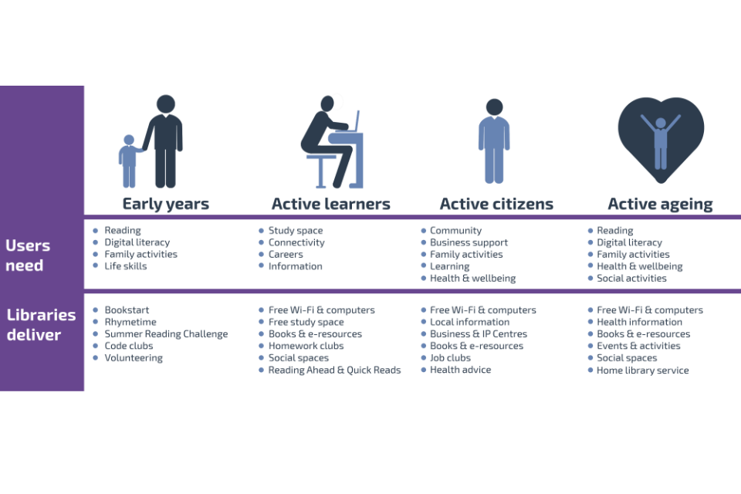

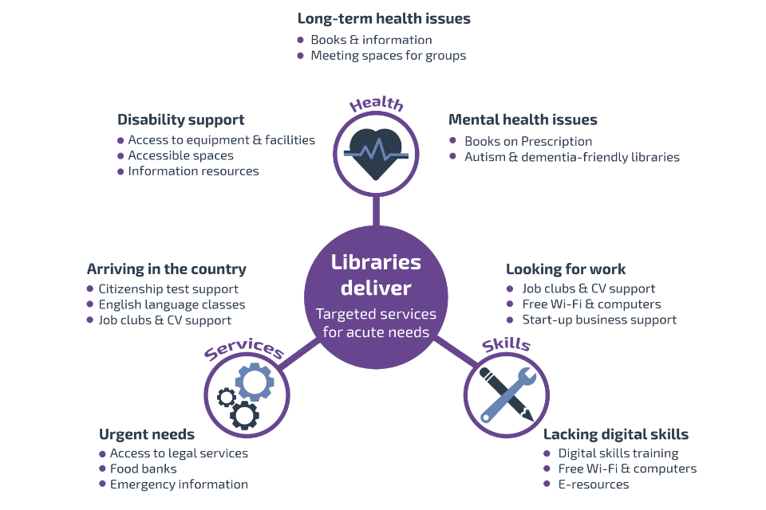

Source: Libraries Deliver: Ambition for public libraries in England 2016-2021

**Appendix 3 – Summary Figures**





Note: the premises costs represent a £10k reduction from current levels in year 1, and a £20k reduction from current levels in year 2 and beyond.



Note re Cockerton:

In addition there would be £5000 rent from DBC for library at Cockerton, and specialist librarian support. There is also an assumption of generating a minimum of £12,000 per year to cover the remainder of Cockerton premises costs. These figures have been built into the overall summary.

**Appendix 4 – Income Assumptions**

Room Hire – based on 25% utilisation and £17.50 per hour average hire rate for large room, £10 per hour average hire rate for small room (assumptions agreed with DBC)

Cafe – 100 hot drinks per day plus cold drinks, sandwiches and cakes/snacks. Total sales of £107,000 per annum, generating profit of £41,000 per annum. This is a conversion rate of 38%. Figures were developed with input from a local cafe manager. Comparisons include Costas at Waterstones which generates sales of £213,000 per annum. Industry standard conversion rate is 50-60% so we feel the figures are very achievable. We are aware of a DBC cafe that has sales of £80,000 and profit excluding premises costs of £18-20k which is only a 25% conversion rate, however industry research suggests this is very low conversion rate.

Parties – based on a new book themed childrens party offering, generating £6 profit per child, 4 parties per week.

Shop Area – based on 10% conversion rate from footfall, average £2.50 spend.

Events – based on 12 music events and 20 seasonal / creative events per year.

Pop-up shops – based on 12 weekday and 12 weekend day pop-up shops per year, plus 2 seasonal fayres.

Reprographics – figures from Teesside University suggest there could be considerable additional income to be made if current services offering was to be expanded. The figure included is a low estimate, based on the need to further understand the potential market in Darlington, plus DBC’s current plans to upgrade existing printing facilities.

2nd Hand Books – based on a similar scheme at Richmond station which generates £100 per week.

**Appendix 5 – Plans for Cockerton**

The proposal to save Cockerton Library is based on the continued administration of the building as a library/community hub by a new Darlington Libraries Trust which would have professional library support, supplemented by volunteers.

Supporting the venture would be local organisations, individuals living in the community and members of the business community. A member of the business community has already expressed an interest in exploring options to support a library remaining at Cockerton.

Saving the library is important because recent impact assessment work by Darlington Borough Counciil stated:

“It is clear from the impact assessment work and the recent needs assessment work that the closure of Cockerton Library will impact a number of vulnerable groups disproportionately. Key impacts are outlined as follows:

- Under 17’s have the highest usage levels of Cockerton Library largely due to the regular visits from three local primary schools and 91% of families indicated that they would no longer use the library service if Cockerton Library closed.

- People with disabilities and those aged 65 and over highlighted that Cockerton Library has free parking within its grounds and indicated they would not be able to using Crown Library due to the difficulty in accessing the town centre library. Impacts of being no longer able to use the library service centred on impacts to independence and mental health. “

**Under our proposals, the library would contain:**

A library run by professional librarian staff supported by volunteers – we note that council officers have indicated that they would provide some support, ie computers and book replenishment plus a librarian a day a week – we would hope that given the community commitment to saving the library the number of days a librarian was available could be extended as a gesture of goodwill, as this has been included in the figures for option 3. The Library will need a constant supply of books and it would be helpful if the council would agree to undertake both the book refresh and the reference library enquires.

An IT centre along the current lines for people to access information online, apply for jobs, benefits etc, staffed by volunteers – some local parents have already agreed to support the volunteers in running this. Cockerton has the lowest up-take of IT in Darlington. Given that all benefits must now be applied for on-line, the IT will be an important community resource and will need professional support.

**Options for income generation:**

* A small / pop up cafe run by the friends group could potentially be set up
* A number of people expressed an interest in using the space, eg the space could be used for a knitting group, exercise classes, art classes, pre-school reading groups, IT and other community activity, including arts and music performances.
* A volunteering organisation which organises visits of vulnerable people at difficult times of their lives has already expressed an interest in taking space in the building.
* Sponsorship from local businesses / schools could be explored further.
* Fundraising events could be held.

**Volunteers**

When the council first talked about the idea of closing Cockerton a steering group from the local community was put together. There were a number of people out there who wanted to help. Evolution ran a volunteer day last year to test the waters in Cockerton and found that more than 60 people registered an interest in volunteering for the Library. It would need a volunteer co-ordinator and some library support from the council.

**Suggestions for a way forward.**

* Arrange a meeting with all the businesses to bring them up-to-date with the proposals and seek sponsorship.
* Arrange a meeting with the heads of the schools to ascertain usage and levels of support.
* Decide on the opening hours of the Library.
* Decide on the time slots for groups and a session fee.
* Keep the Library open with Library staff but appoint a volunteer co-ordinator
* Begin to engage with the community to come forward to take up volunteer slots in the Library with the aim of filling the slots over a six month period.
* Start an information campaign in the community by using social media, free newspapers, Darlington Together and the Library to encourage people to come forward to help.

**Summary**

We are confident that sufficient income could be generated to cover Cockerton premises costs. In addition to £5000 rent charge to the council for using Cockerton as a library space, approximately £12,000 would need to be generated to cover premises costs (though there is potential to reduce some of these costs).

Note: It is necessary to charge a minimal level of rent to DBC, as otherwise questions would be asked when applying for funding, given that library provision is a statutory service. This has been factored into the figures presented for Option 3.

**Appendix 6 – mobile library**

A needs assessment would need to be undertaken (if it hasn’t already been done) on the mobile library to understand the areas where this service is most needed, and whether there is significant enough need to make the case for retaining the mobile library.

Sponsorship would be sought for the bus itself if the needs assessment shows there is a good case for retaining the mobile library.

Librarian support for this is built into the figures presented for Option 3, ie 1 full time librarian to support Cockerton, Mobile and Dolphin Centre Quick Picks.

**Appendix 7 – Successful Local Community Trusts**

The Station in Richmond is an excellent example of a thriving building that has been taken over and run by the community. Richmondshire Building Preservation Trust (RBPT) was established in 2003 by a group of local community volunteers to lead the renovation of the Victorian railway station in Richmond.

Another example is Onsite in Stockton, and the charts below show how successful Community Asset Transfer there has been in increasing income, footfall, and use of community buildings by a wide range of groups.

In order to facilitate this Stockton Borough Council provided the following start up:

* + £200k revenue support pump prime grant
  + £200k building improvement grant to be drawn upon when needed







Appendix 8 – Examples of Potential Sources of Income

We have looked at a number of potential income sources, however experience from other Trusts has shown that there is a wide range of potential sources of income from social, educational, health focussed and recreational activities, including:

- Arts Groups

-  Folk Dance

- Local History Club

- University of the third age classes

- Independent churches

- Music Groups (Evenings)

- Scrabble Club

- Public Speaking Club

- Flower arraging

- Pottery

- Playgroups

- Drop in Sessions

- Deaf Group

- Probation Service

- Pray Group

- Choirs

- Quilting Group

- Friends of Library

- Councilling

- Private Tuition

- Nursery

- Ward Surgeries

- Bridge

- Pilates

- International Women

- Calligraphy

- Stamp Club

- Wine Circle

- Camera Club

- Craft

- Mediation Evening

- Slimming Clubs

- Day Services

- Blind Group

- Cactus Society

- Foster Carers

- Youth Club

- Brownies

- Stain Glass

- Yoga

- Remote Control Cars Race night